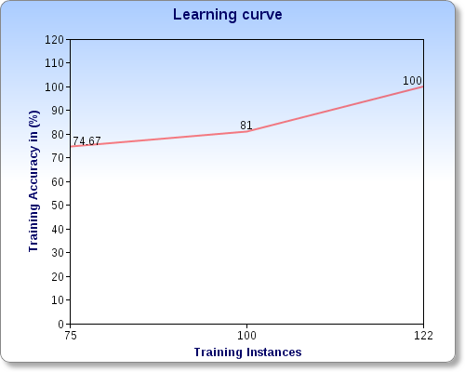

For train-3.dat and test-3.dat files:

|  |  |  |  |  |  |
| --- | --- | --- | --- | --- | --- |
| The Accuracy on training set for 75 instances:74.66666666666667%  The Accuracy on test set for 213 instances:47.68518518518518%  The Accuracy on training set for 100 instances:81.0%  The Accuracy on test set for 213 instances:64.81481481481481%  The Accuracy on training set for 122 instances:100.0%  The Accuracy on test set for 213 instances:87.5%  **As expected, the learning accuracy increases with increasing number of training instances.** | | | | | |
|  | | | | |  |
|  |  |  |  |  |  |
|  | | | | | |
|  | | | | | |
|  |  |  |  |  |  |
|  |  |  |  |  |  |
|  | | | | | |
|  | | | | | |
|  | | | | | |
|  |  |  |  |  |  |
|  |  |  |  |  |  |
|  | | | | |  |
|  | | | | | |
|  |  |  |  |  |  |
|  |  |  |  |  |  |
|  | | | | | |
|  | | | | | |